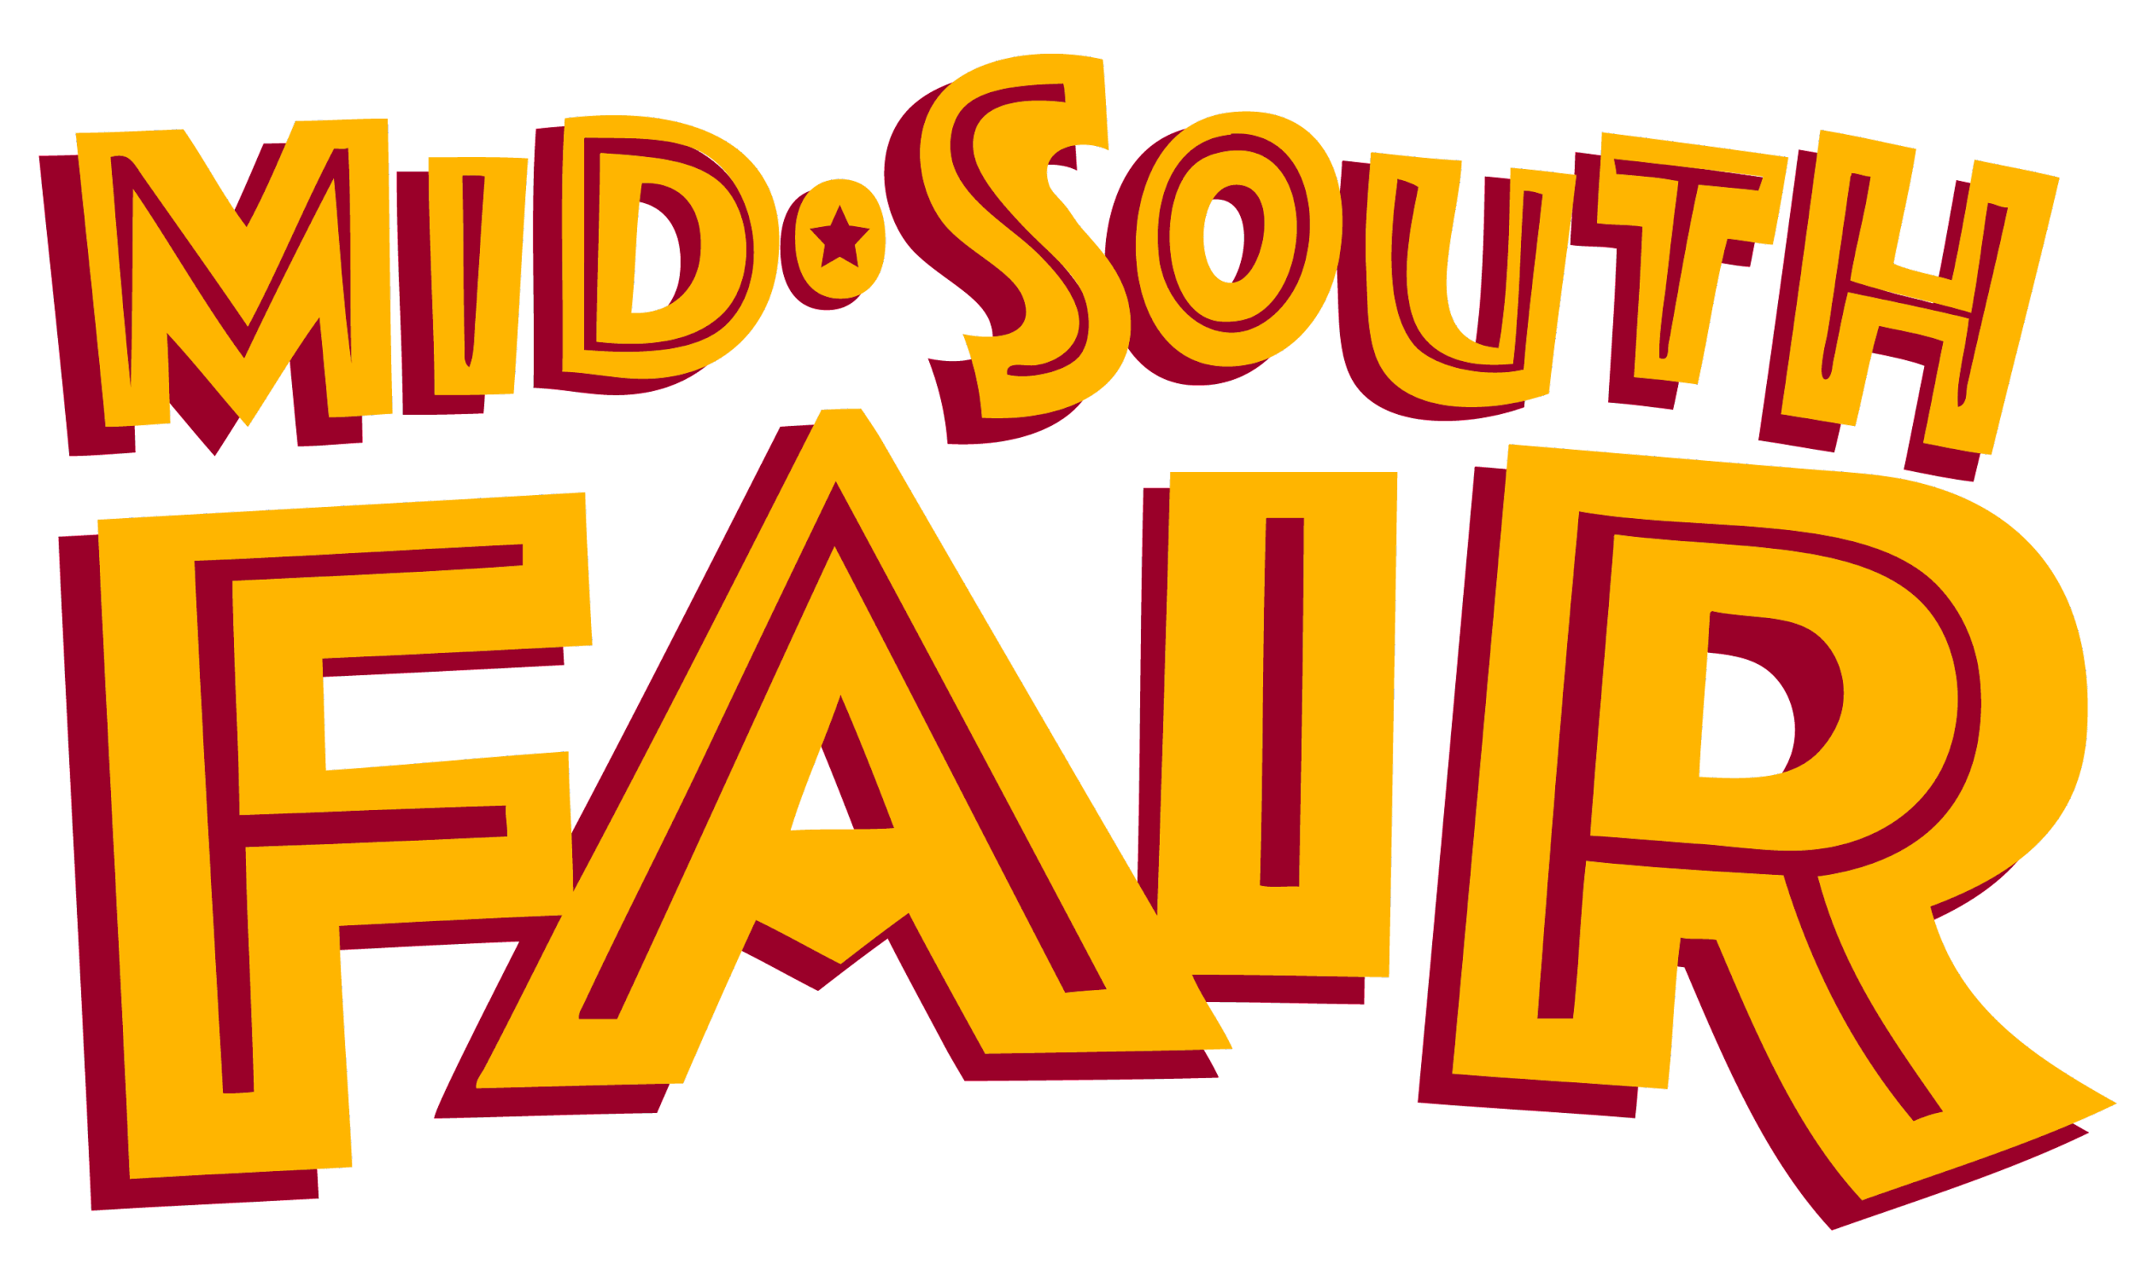
2021 spokesKID website copy

Mid-South Fair poster contest schedule

- Submit digital versions of original artwork in PDF format to midsouthfair@landerscenter.com.
- Deadline to submit is Aug. 31.
- Winner chosen Sept. 2.
- Poster available for sale and on display during 2021 Mid-South Fair from Sept. 23-Oct. 3.

